**1.Arduino UNO platform-------Color LED**

1. **Preparation**

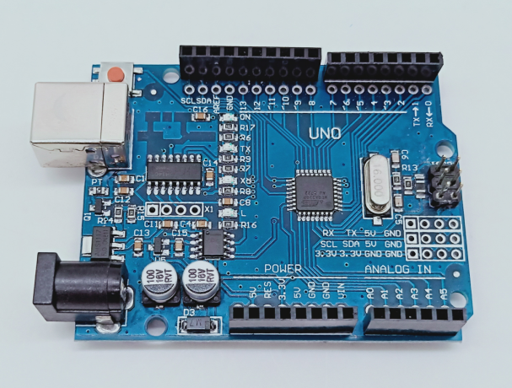

1-1 Arduino UNO board

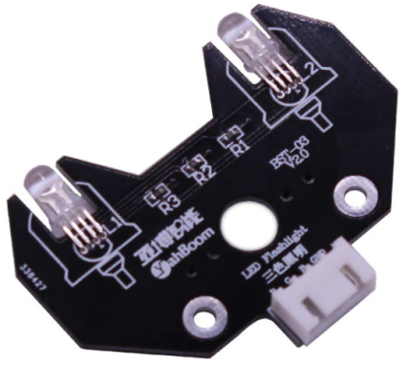

1-2 RGB module

1. **Purpose of Experimental**

After the code upload is completed, the delay is 2s, and the lights of 7 different colors are displayed cyclically.

1. **Principle of experimental**

3 LEDs (red, green, blue) are packaged in the RGB lamp module. We can mix different colors(256*256*256) by controlling the brightness of the three LEDs.

According to the circuit schematic, the RGB lamp is a common cathode LED, one pin is connect to GND, and the remaining three pins are respectively connected to the port 11, 10, 9 on the Arduino UNO board. Each LED needs to be connected in series with a 220Ω resistor as the current limiting resistor. We can control the LED by controlling the corresponding pin to be high level of Arduino UNO board.

1. **Experimental Steps**

4-1 About the schematic

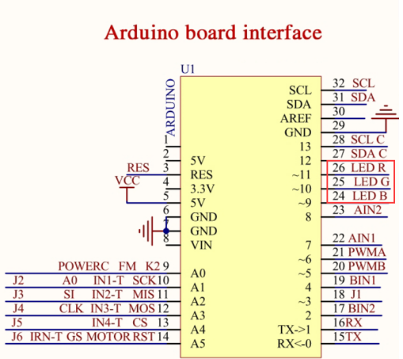

4-1 Arduino UNO interface circuit diagram

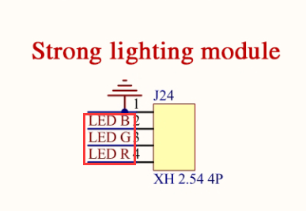

4-2 RGB module interface circuit diagram

4-2 According to the circuit schematic:

LED_R-----11( Arduino UNO)

LED_G-----10( Arduino UNO)

LED_B-----9( Arduino UNO)

4-3 About the code

1. We need to open the code of this experiment: **ColorLED.ino**, click“**√**” under the menu bar to compile the code, and wait for the word "**Done compiling** " in the lower right corner, as shown in the figure below.

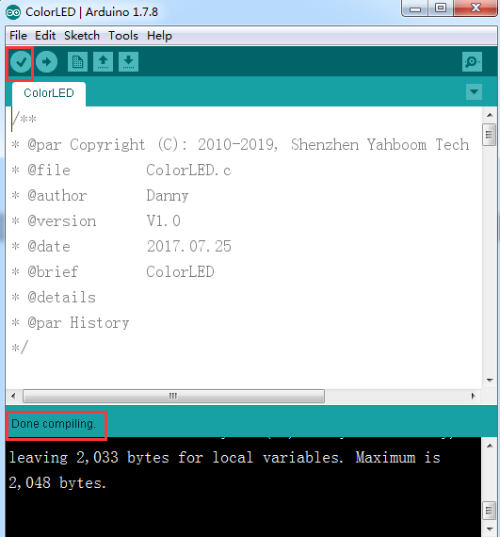

1. In the menu bar of Arduino IDE, we need to select 【Tools】---【Port】--- selecting the port that the serial number displayed by the device manager just now, as shown in the figure below.

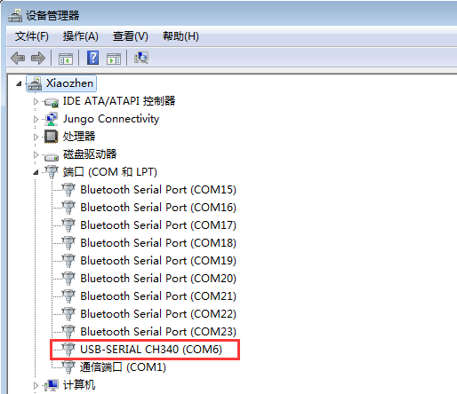

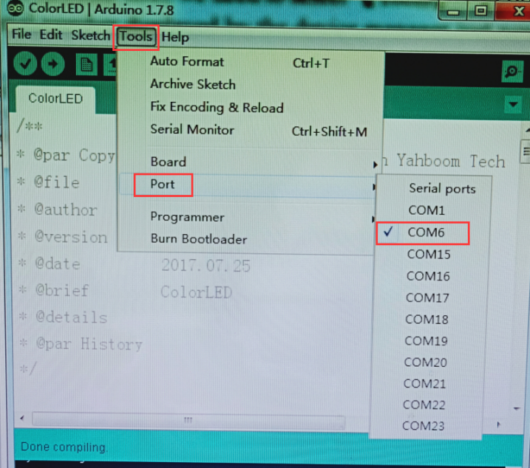

1. After the selection is completed, you need to click “**→**”under the menu bar to upload the code to the Arduino UNO board. When the word “**Done uploading**” appears in the lower left corner, the code has been successfully uploaded to the Arduino UNO board, as shown in the figure below.

